August 31, 2015  
 **Certification**

**Park IP Translations**

This is to certify that the attached translation is, to the best of my knowledge and belief, a true and accurate translation from [source language] into [target language] of the document with the bates number: [single bates #].

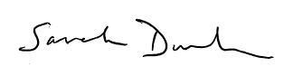

Sarah Dunham

Project Manager

Project Number: [project #]